CURRICULUM VITAE  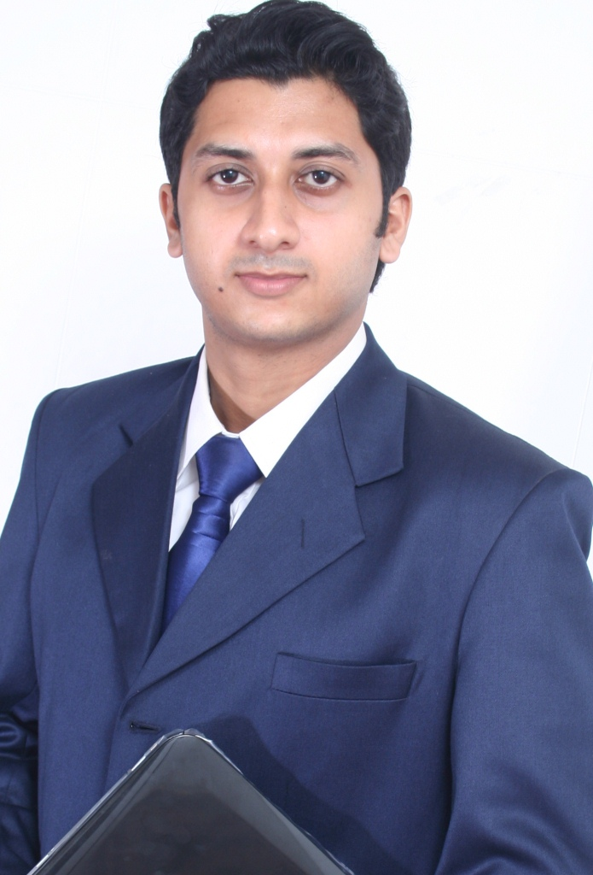  SURAJ ROYCHOWDHURY  Corresponding Address  VILLAGE-DAGABAN,CHAKPARA,P.S.-LILUAH,HOWRAH-711204  Permanent Address: do  E-Mail :  surajroychowdhury@yahoo.in  Contact No.09051803109  Personal Information:  Date of Birth: 16/12/1987  Mother’s Name:  SURANJANA ROYCHOWDHURY  Father’s Name:  PRABAL ROYCHOWDHURY  Sex : Male  Nationality : Indian | OBJECTIVE  I am looking for a challenging environment where I can contribute my full efforts to the organization and grow along with the organization by providing reliable services.  CAREER CONTOUR  HSBC Securities Services,Kolkata  Profile:Fund Administrator,Fund of Hedge Funds April’12 onwards  - Responsible as the fund maker and checker in the pricing & reconciliations team across Dublin having hands on experience of working in Geneva and TLM.Have worked on complex fund structures like Standalone and Master-Feeder.  - In line with the same the following activities are performed:  - Cash Reconciliation  - Holding and Market Value Reconciliation  - Spot & Forward Reconciliation  - Performing Client Reconciliation  - Liaise with the jurisdiction of day to day issues and discussion with the team to resolve them without any PLA breaches.  - Attend the weekly calls with Client/Partners of HSBC.  - Collated Ageing Analysis,Volume Updation & other MIS data for the team.  - Have been to Colombo on a two week assignmnent on Business  Contunuity Plan  PROFESSIONAL QUALIFICATION  ACADEMIC QUALIFICATION  - Bachelor of Commerce from Heramba Chandra College under University of Calcutta in 2009  - Higher Secondary Education from Salt Lake School(2006)  - Secondary Education from S.T. Francis Xavier School  AREA OF INTEREST  - Fund Pricing & Reconcilliation  - Tax planning  - Wealth management  - Equity research
  QUALIFICATION | SPECIALIZATION | COLLEGE | YEAR OF PASSING
  Postgraduate Diploma in Financial Planning | Retail Finance | International College of Financial Planning | 2012
  NISM Series-V A Mutual Fund Distributors Certification Examination | Mutual Funds | National Stock Exchange (NSE) | 2011-12  (68%)
  Derivatives Market (Dealers) Module | Derivative Market | National Stock Exchange (NSE) | 2011-12  69%
  Capital Market (Dealers) Module | Capital Market | National Stock Exchange (NSE) | 2011-12  68.75%
  MCX Certified Commodity Professional | Commodity Market | Multi Commodity Exchange | 2011-12  (85%)
  Bhavishya Jyoti | Fundamental Course on MS Office, Internet | NIIT | 2003
PROFESSIONAL QUALIFICATION

QUALIFICATION | SPECIALIZATION | COLLEGE | YEAR OF PASSING
Postgraduate Diploma in Financial Planning | Retail Finance | International College of Financial Planning | 2012
NISM Series-V A Mutual Fund Distributors Certification Examination | Mutual Funds | National Stock Exchange (NSE) | 2011-12  (68%)
Derivatives Market (Dealers) Module | Derivative Market | National Stock Exchange (NSE) | 2011-12  69%
Capital Market (Dealers) Module | Capital Market | National Stock Exchange (NSE) | 2011-12  68.75%
MCX Certified Commodity Professional | Commodity Market | Multi Commodity Exchange | 2011-12  (85%)
Bhavishya Jyoti | Fundamental Course on MS Office, Internet | NIIT | 2003

ACADEMIC QUALIFICATION
- Bachelor of Commerce from Heramba Chandra College under University of Calcutta in 2009
- Higher Secondary Education from Salt Lake School(2006)
- Secondary Education from S.T. Francis Xavier School(2004)

Marital Status: Single  Languages  Known : English  Bengali  Hindi  Hobbies : playing football, cricket, and collection of foreign currency, biking, music and movies.  Passport Status: Available | CO- CURRICULAR ACTIVITIES  - Participated in Quiz at school level.  - Participated in school sport as a captain of cricket team.  - Participated in debate & extempore at higher secondary school, topic was” commerce/ arts which is better”.  - Responsible for organizing team huddles and team building activities on a daily basis.  IT SKILLS  - Profficient with the use of MS Windows,MS Office & Internet Applications.  - Hands on experience in Bloomberg ,Geneva and Report Builder.  DECLARATION  I hereby declare that all the above given information are true and correct to the best of my knowledge.  Place:-Kolkata  Date:  ( SURAJ ROYCHOWDHURY)

